**Video 30:**

Creating a Windows EC2 instance and RAID Group:  
RAID is nothing but a collection of disks putting together and they act as one disk to the OS. In AWS, mostly we use RAID 0 or RAID 10.  
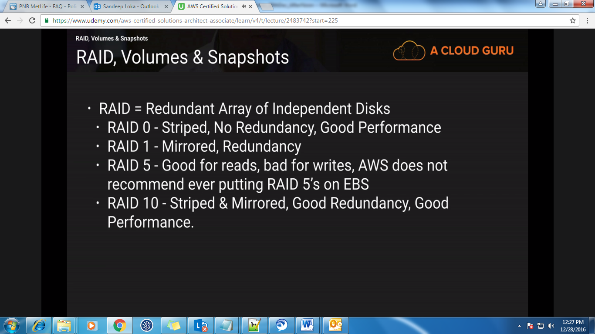

Select the windows server if you want to create a new Windows EC2 instance then under storage you just add the volumes like below. And also for SG, just add new rule with Type as ‘RDP’ and use that SG for this instance.

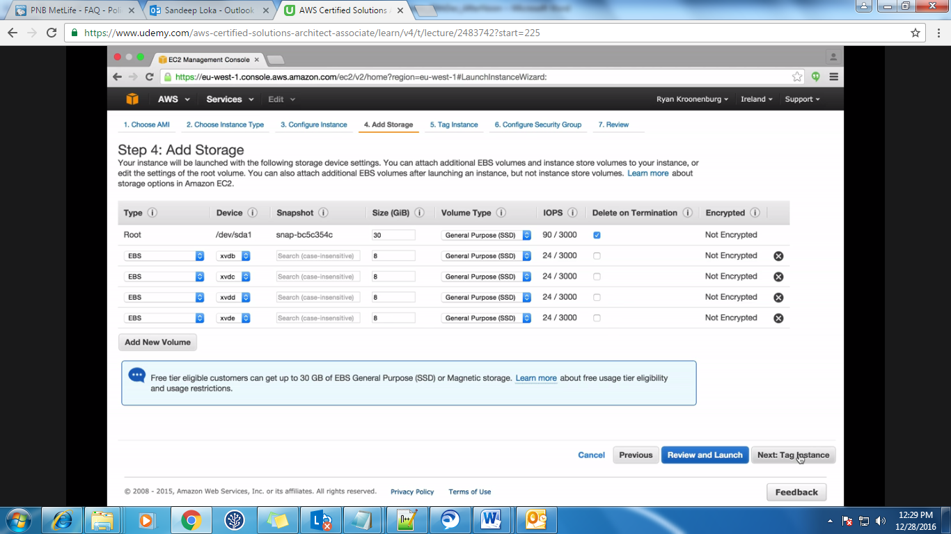

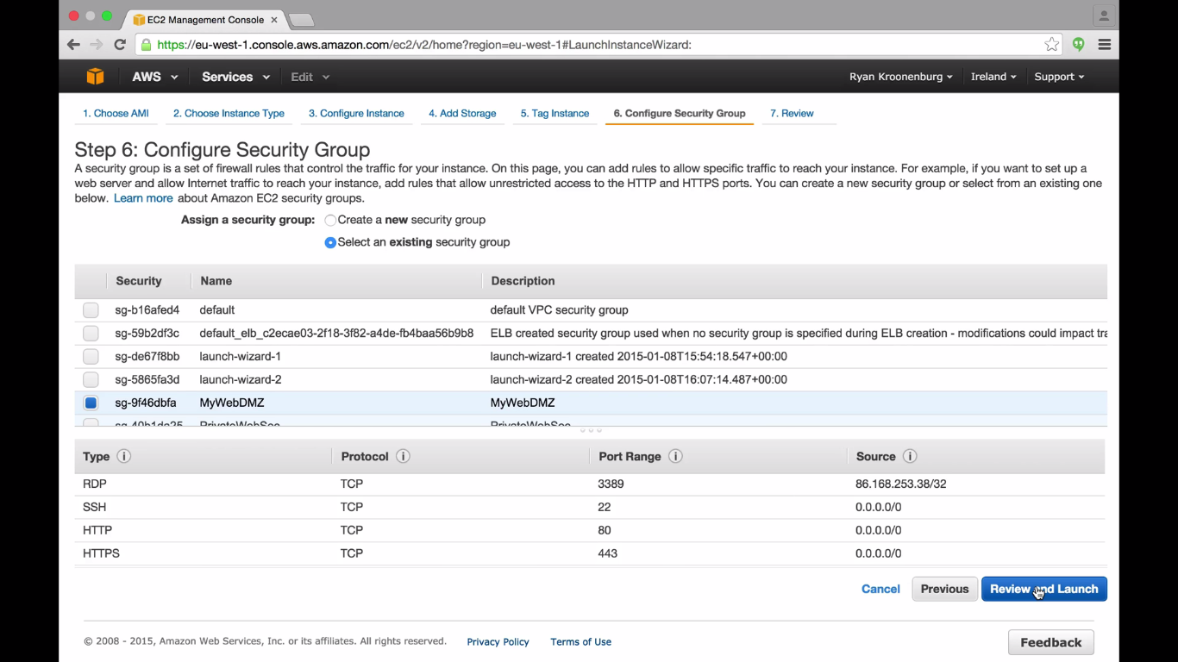

After creating the windows instance, to login to it the username is Administrator and for password go to Actions->Get Windows Password and then browse for the .pem keypair file and then decrypt it.  
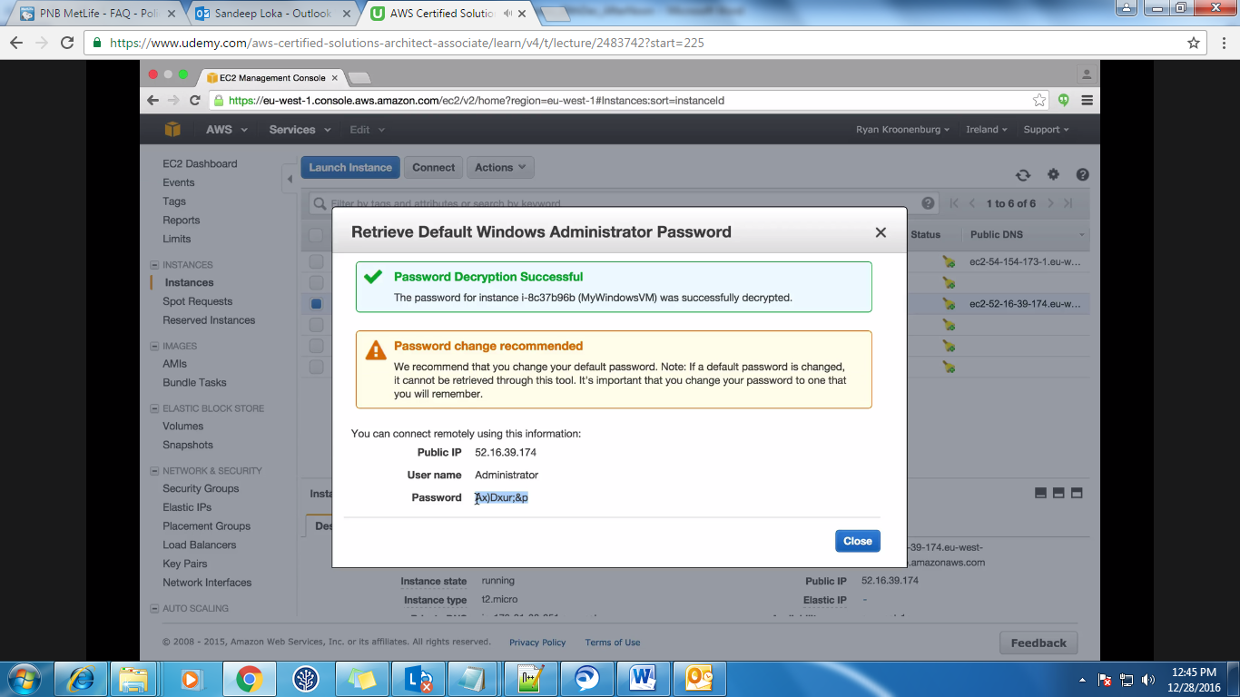  
We use RDP (Remote Desktop Protocol) to login to the windows instance i.e. just give mstsc (Microsoft Terminal Service client) in start and then enter the IP and the credentials.

After logging in, you will see the 5 volumes or disks which we have added and they are already mounted.  
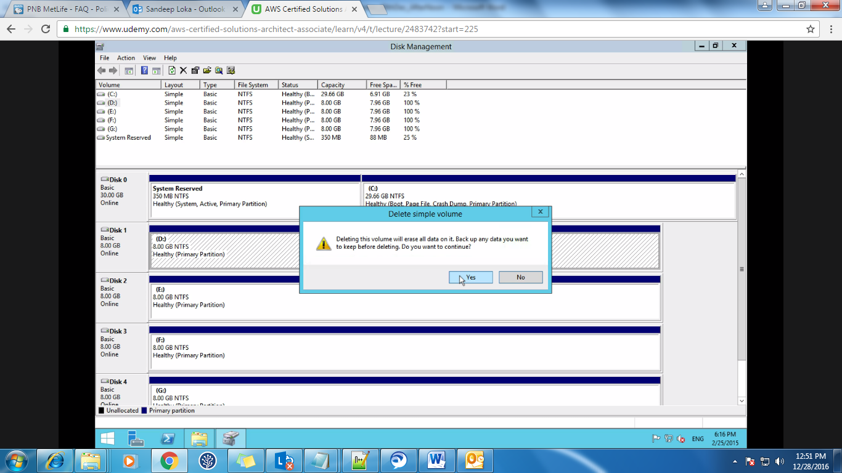  
Right click on Disk 1 to 4 and delete the volumes. After deleting you will see that they are unallocated. Again right click on any one of the disk and select which volume you want to create. Here we will create striped volume.

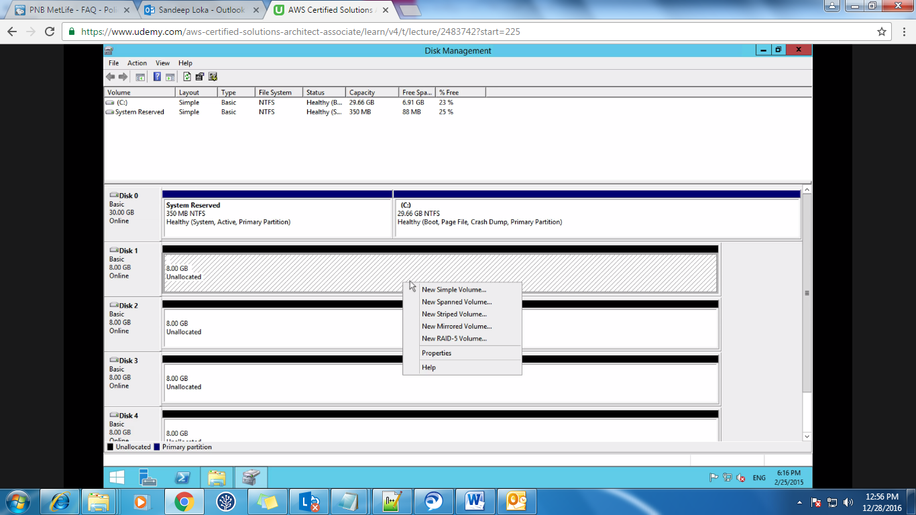

After this, select the Disks which you want to add to this striped volume and name this volume also. Here we are naming it as D: /.

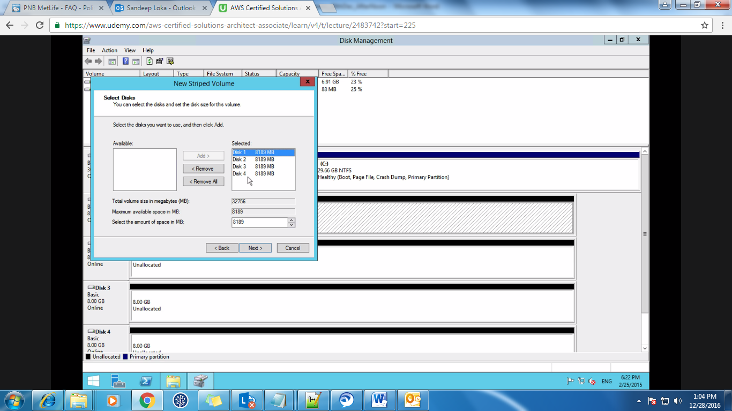

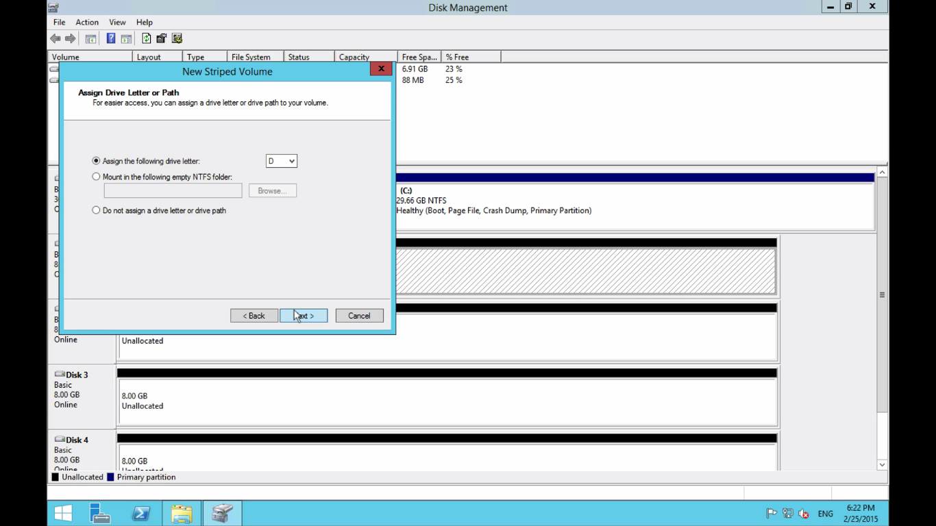

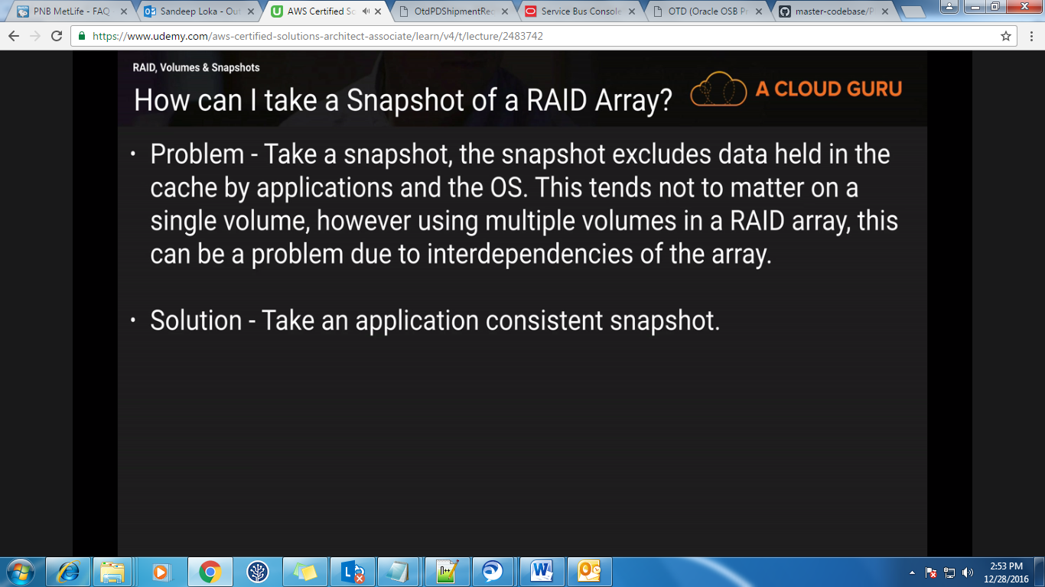  
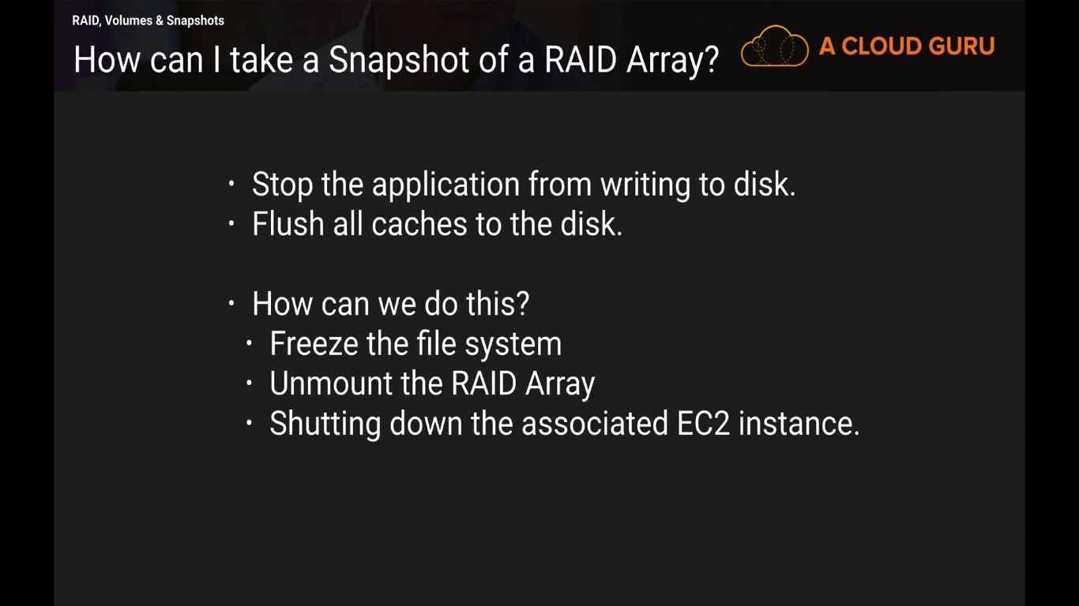

Video 31:  
**Create an AMI:**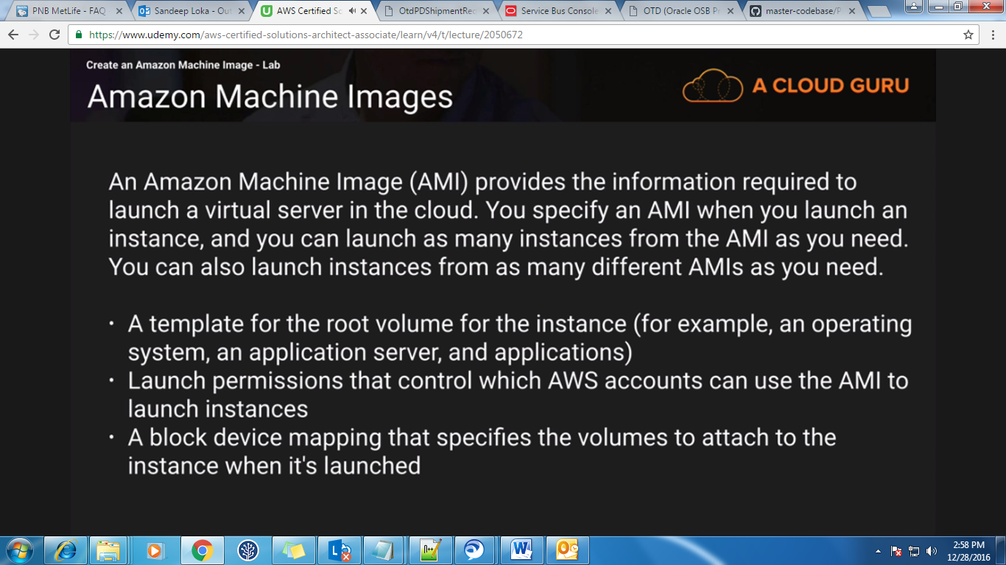

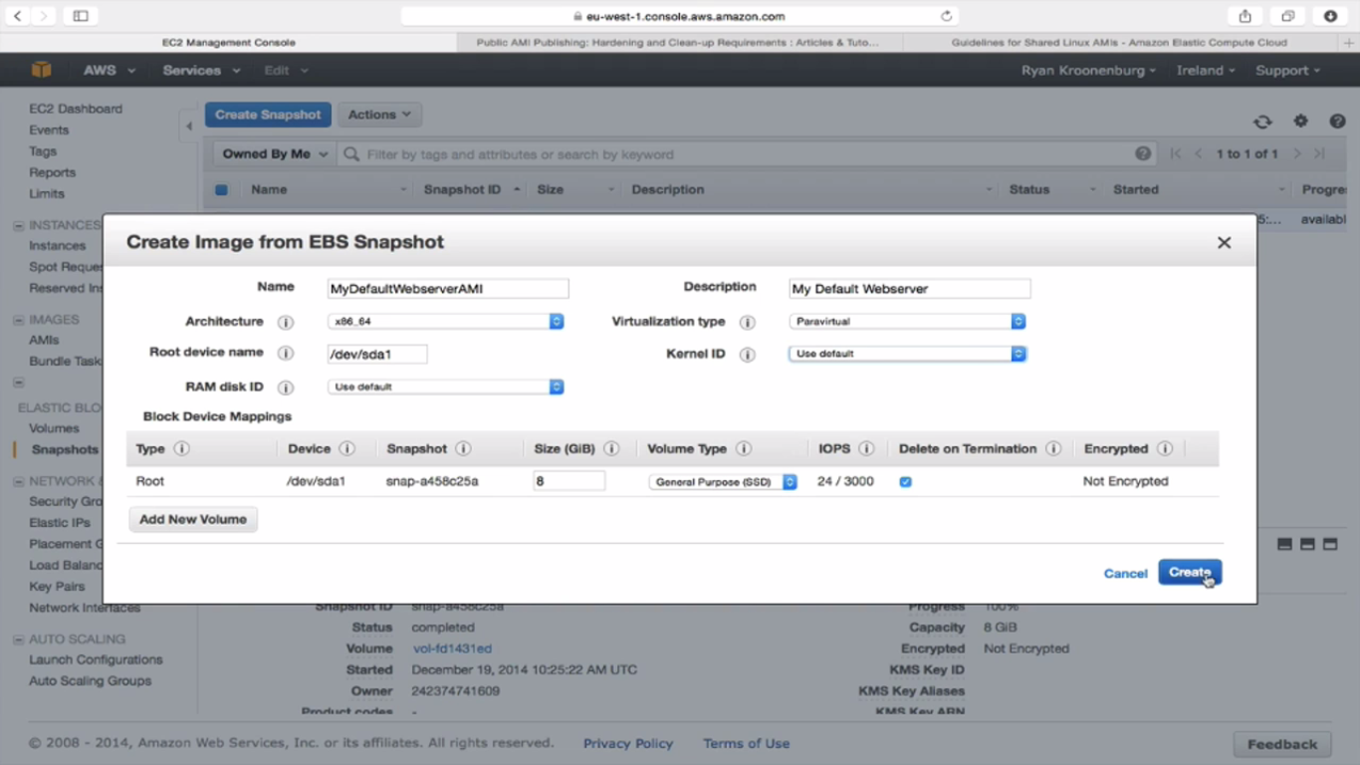  
Click on any instance and then go to volume of that instance and take a snapshot of that volume. Then go to snapshot and create an Image (AMI) from it. This image is by default private. You can make it public also. The AMI’s which are already there and the AMI’s which are created from snapshot, all these AMI’s will be stored on S3 only.AMI is a snapshot of root device volume.

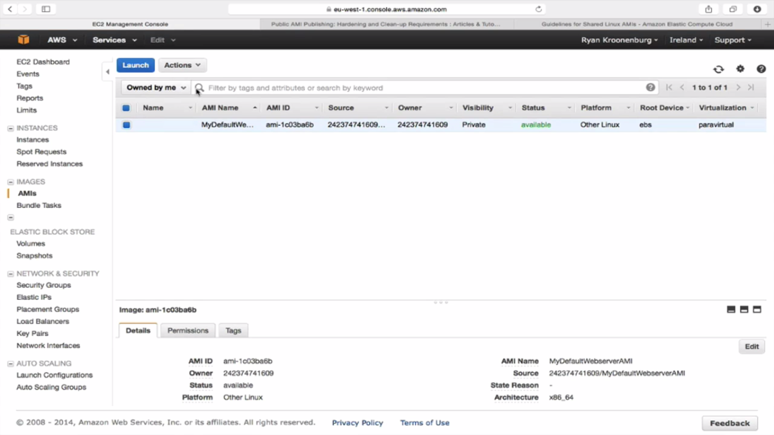

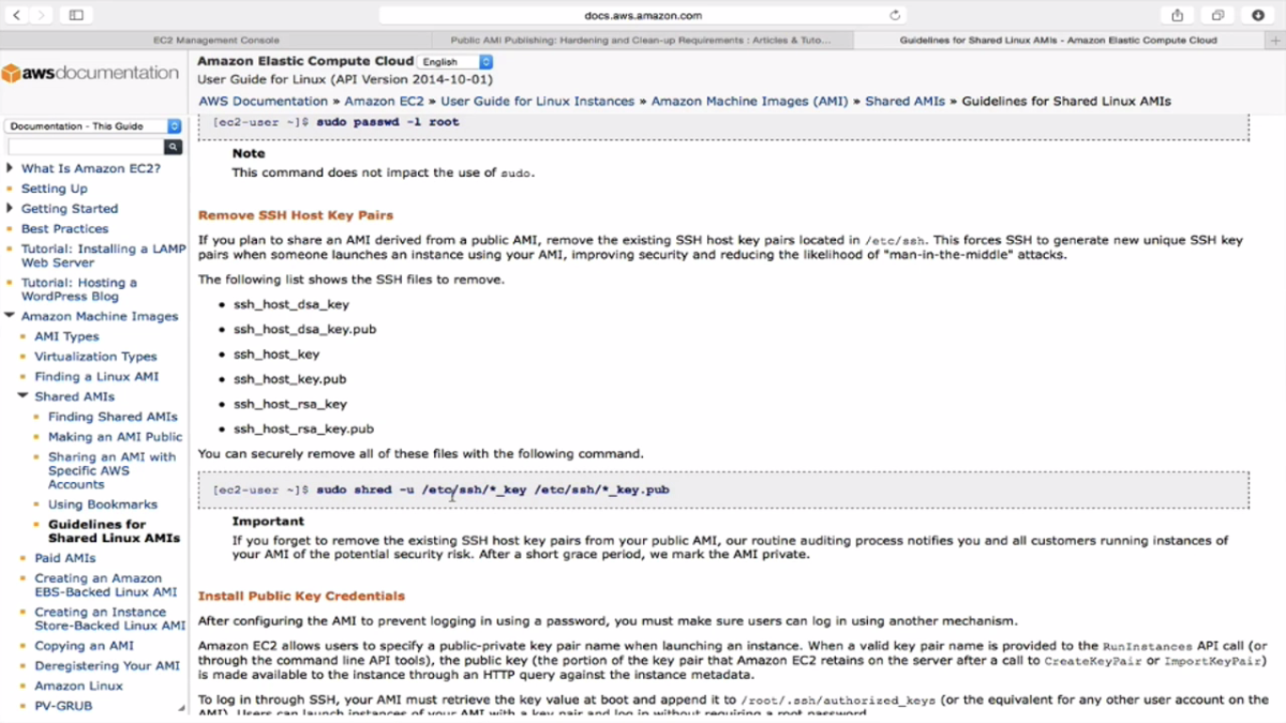

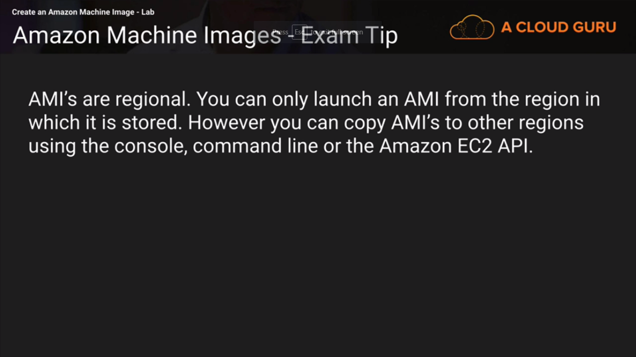

**Video 32:**

**AMI Types (EBS Root volumes Vs Instance Store):**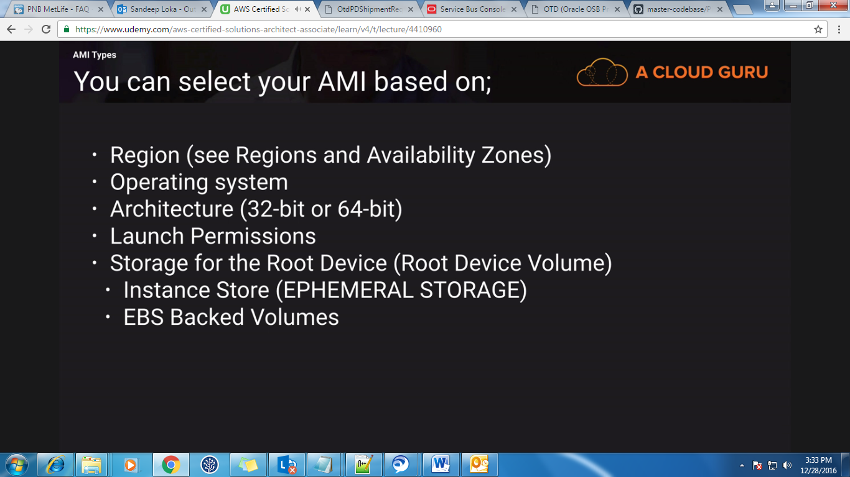If you see the AMI’s, all of them are having the Root Device Type as EBS only.

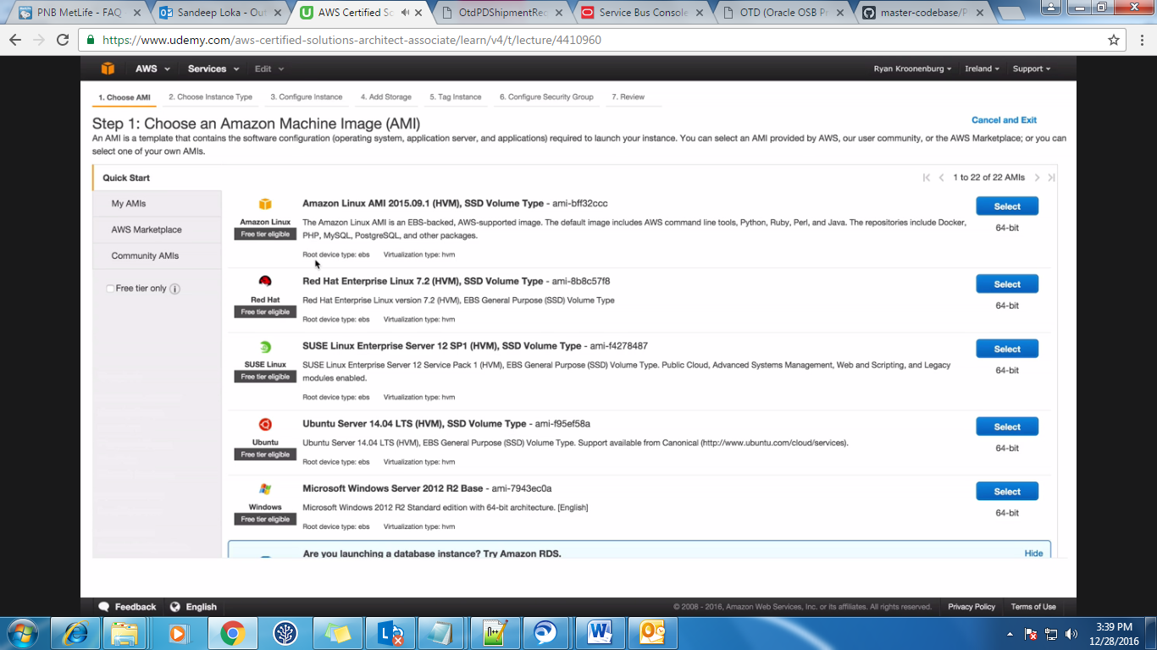  
Click on the Community AMIs then you will see the below screen and under Root device type, select instance store and then select any one of the image. Here we are selecting 3rd image.

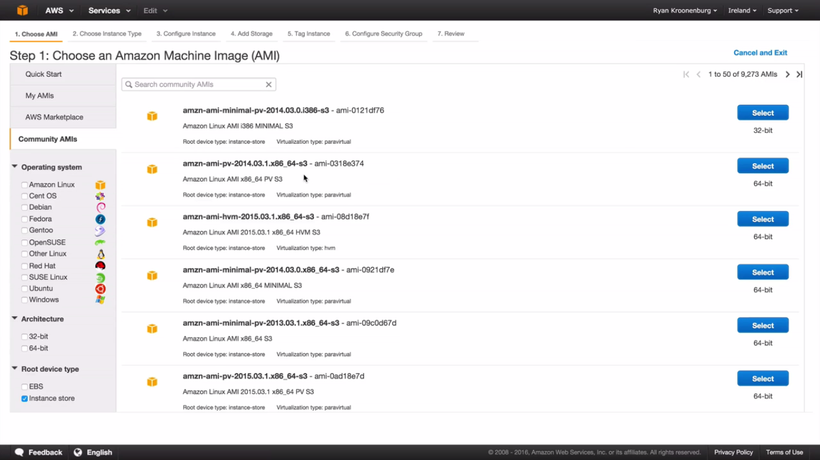And in the storage part, just add another instance storage and also go through the test below step 4.

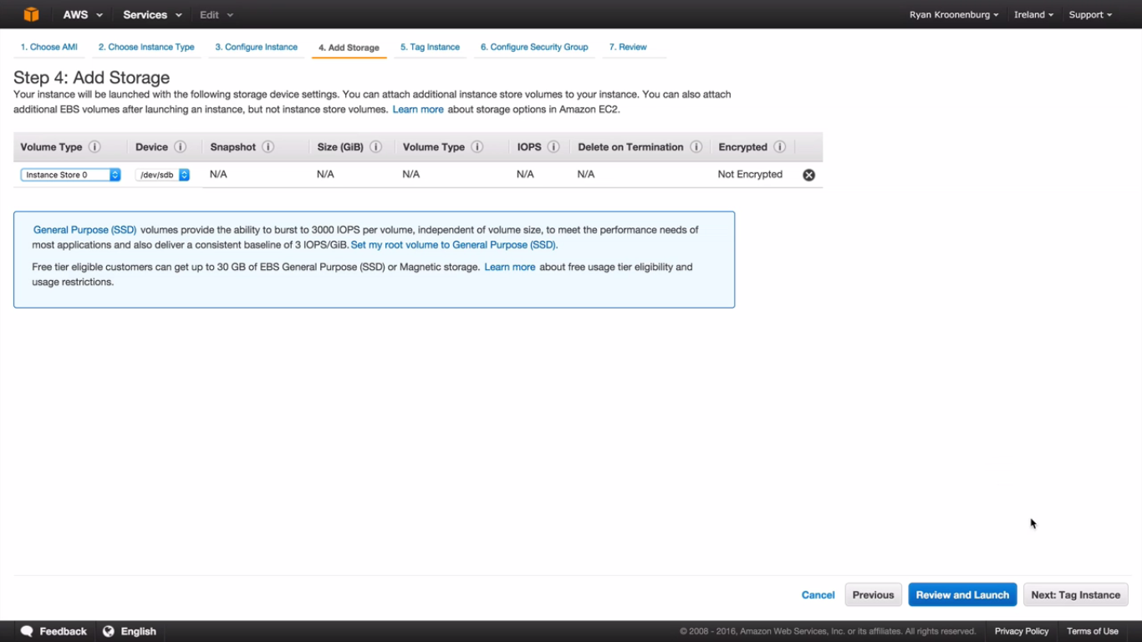Now we have 2 instances. One is instance store based and another is EBS based. Just click on the actions and also on the volumes and other options and check the difference.

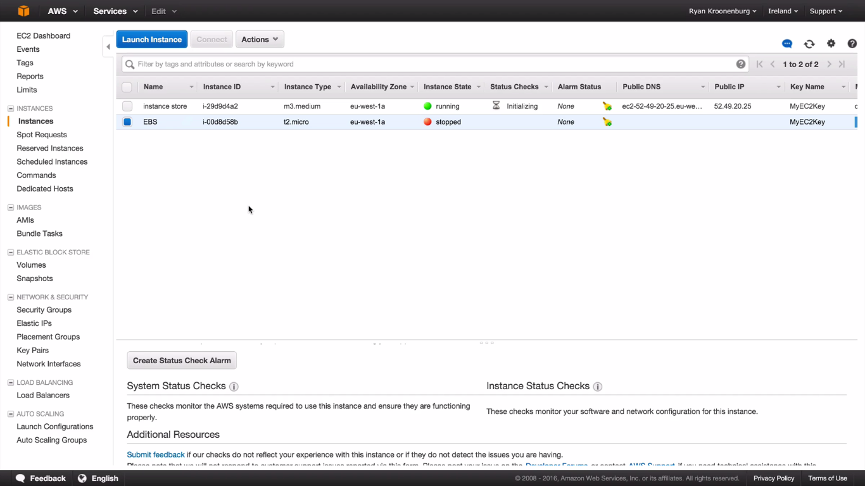

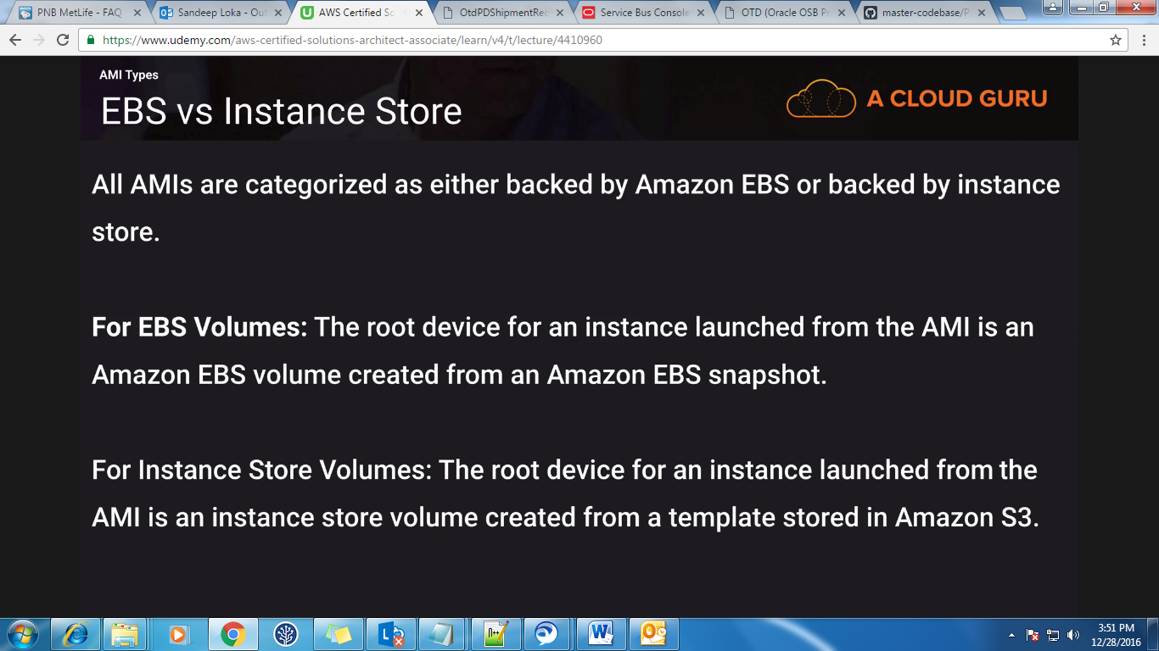

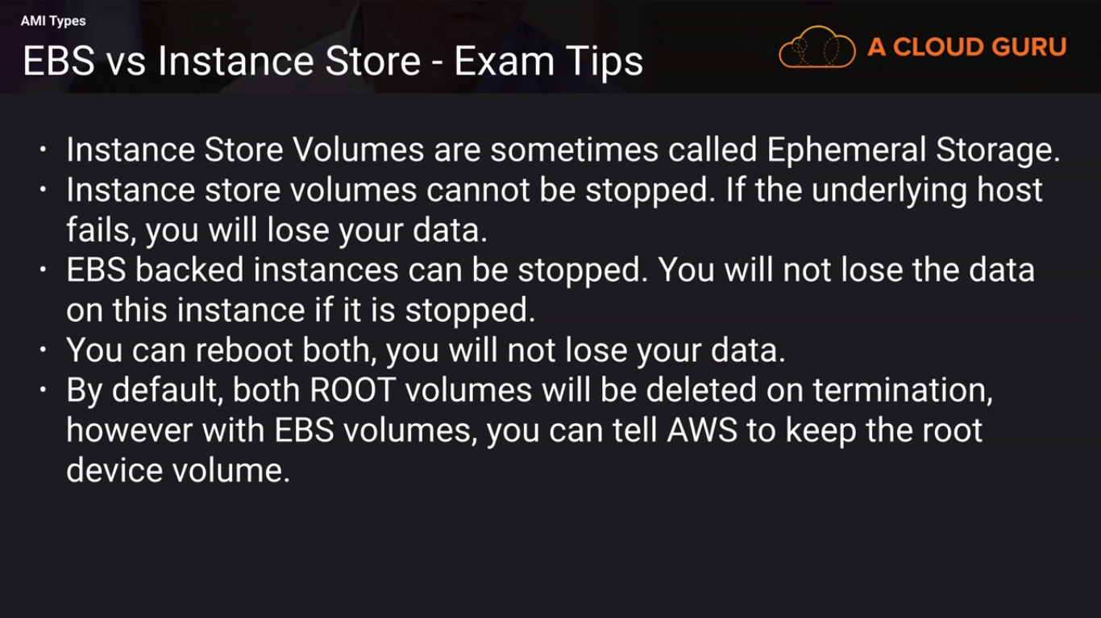

**Video 33:**

**Load Balancers & Health Checks:**Select any instance and click on Load balancers and create a new load balancer.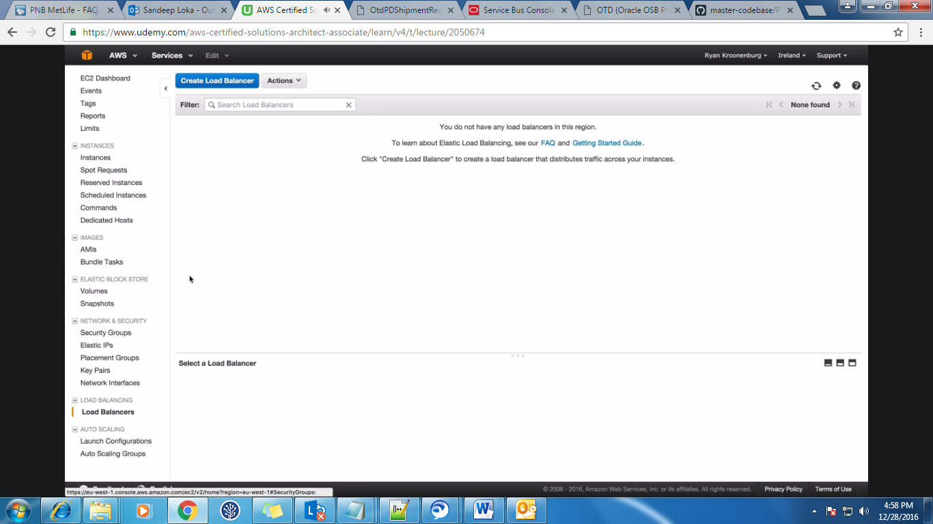  
Select the Load balancer protocol and port and also the Instance protocol and port.  
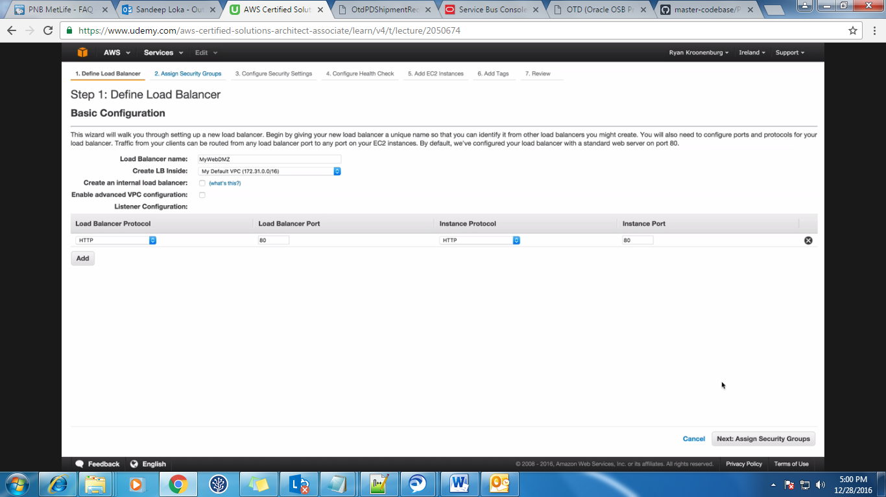  
Also select the SG.

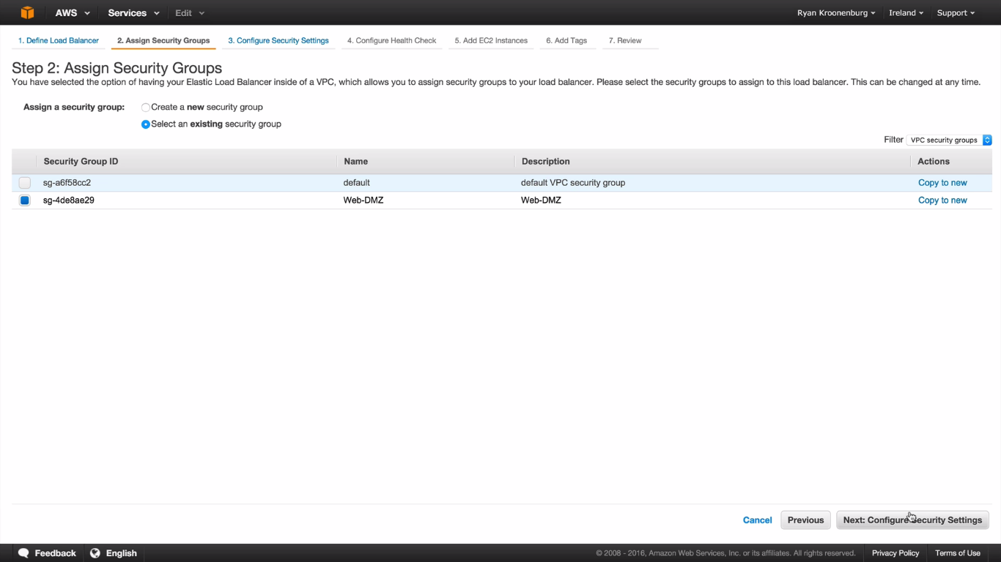Then configure the health checks.

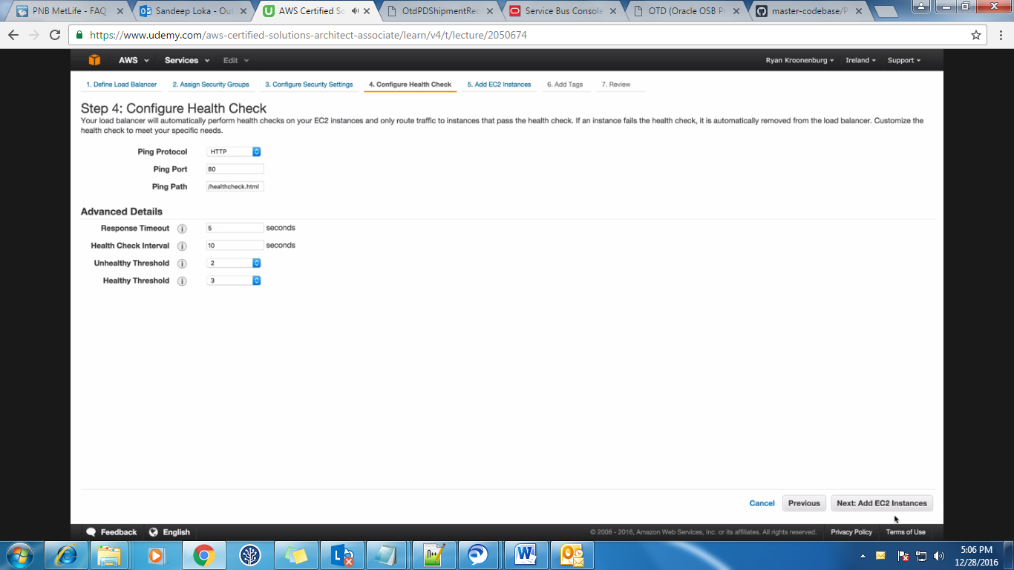Then add the instances on which you want the load balancer to perform health checks.

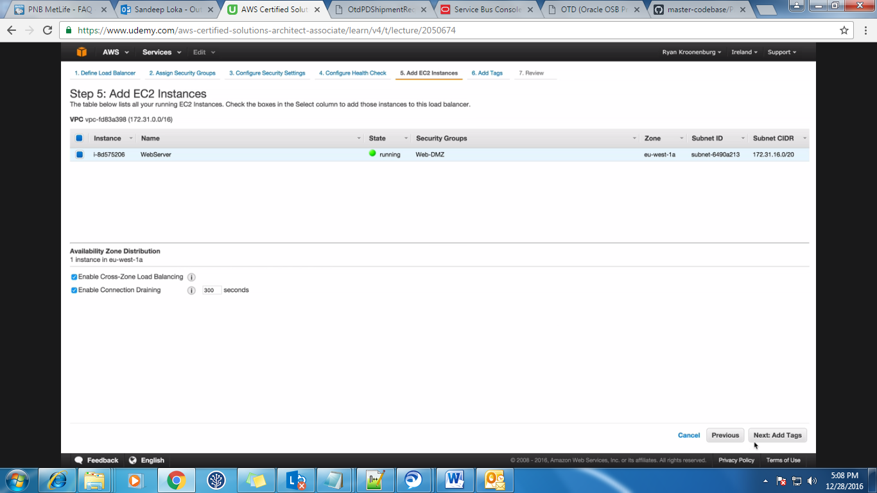

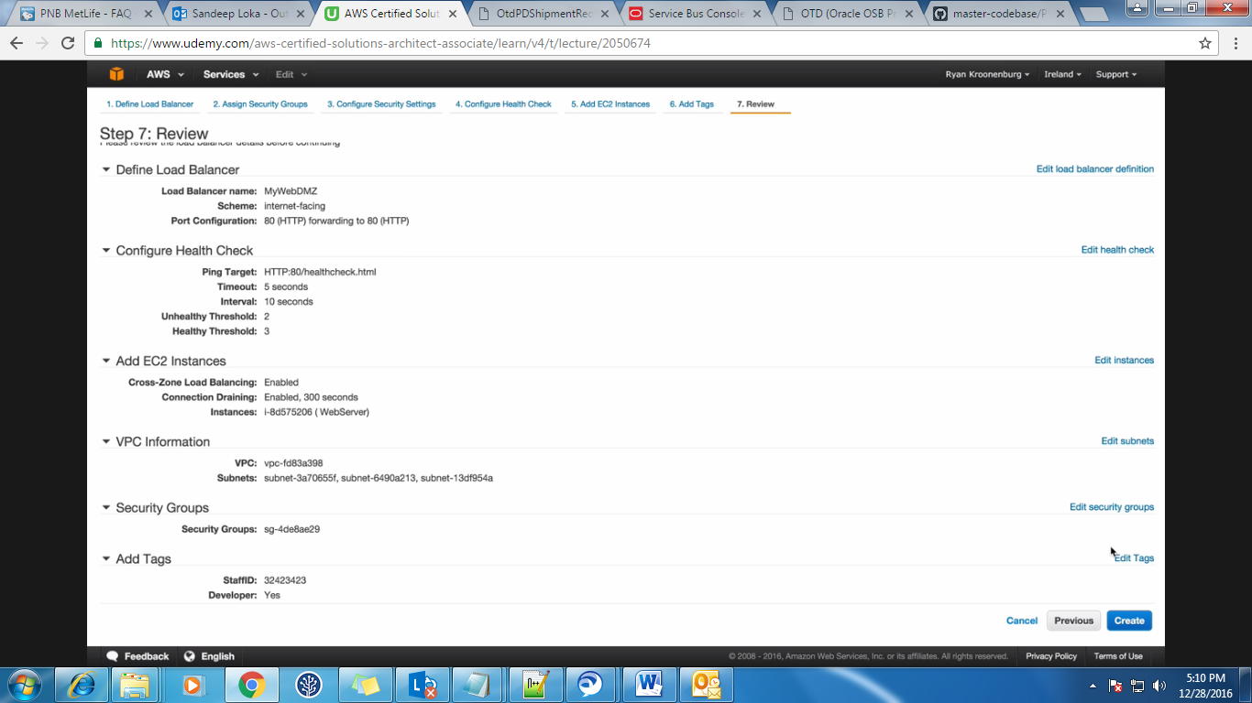After creating load balancers, just go down and check the Health Check tab and other tabs like DNS name etc. Paste these in the browser and it should display the page.

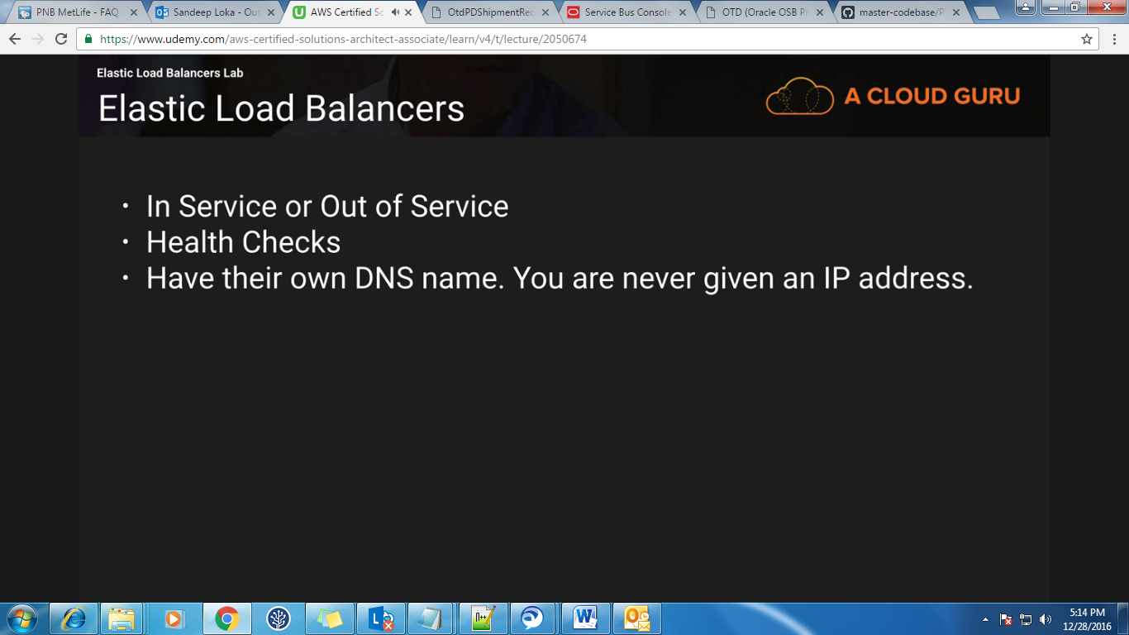

**Video 34:  
Cloud Watch – EC2:**You can see cloudwatch under management Tools in AWS home page.  
All EC2 instances will have basic monitoring enabled. Basic monitoring will happen for every 5 mins.   
If you want the detailed monitoring enabled, then check the below option but it will costs you more. Detail monitoring will happen for every 1 min.

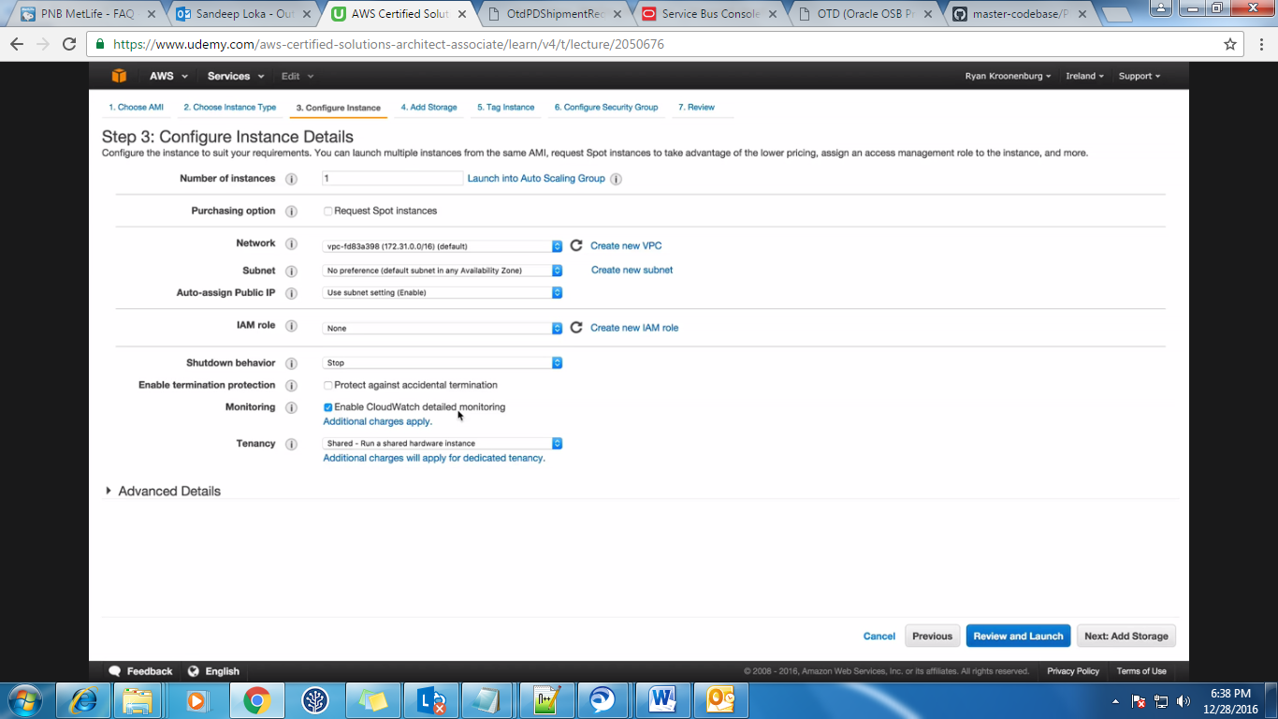

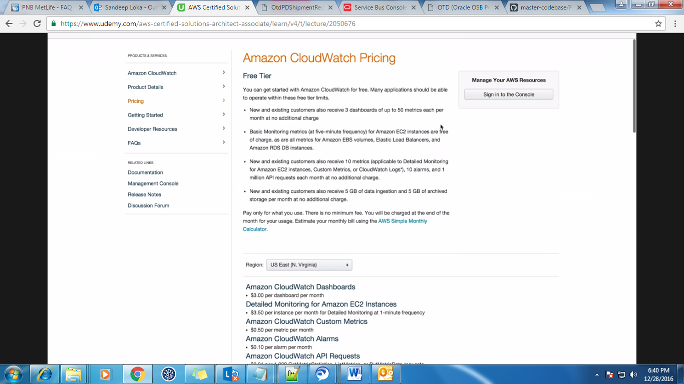Click on CloudWatch under Management Tools and then create a dashboard and if you want to configure the Metrics for EC2 Metrics then click on them and select CPU Utilization or whichever you want.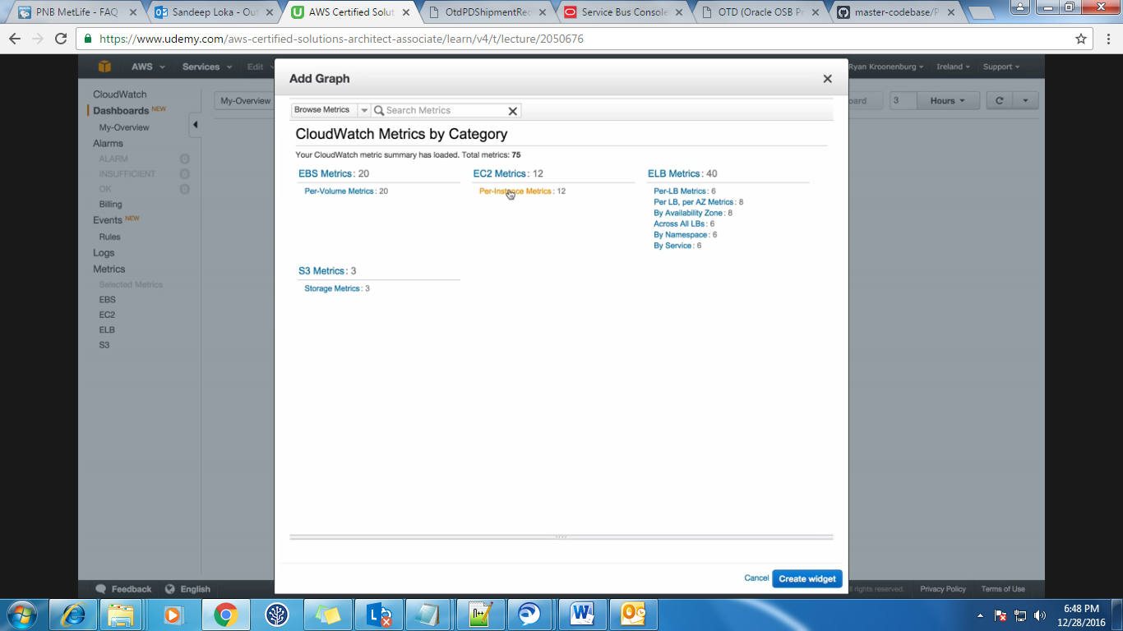  
Sometimes in the exam they may ask you about what all the Metrics you will see in the Graph. You will see metrics related to CPU, Disk, Network and status.

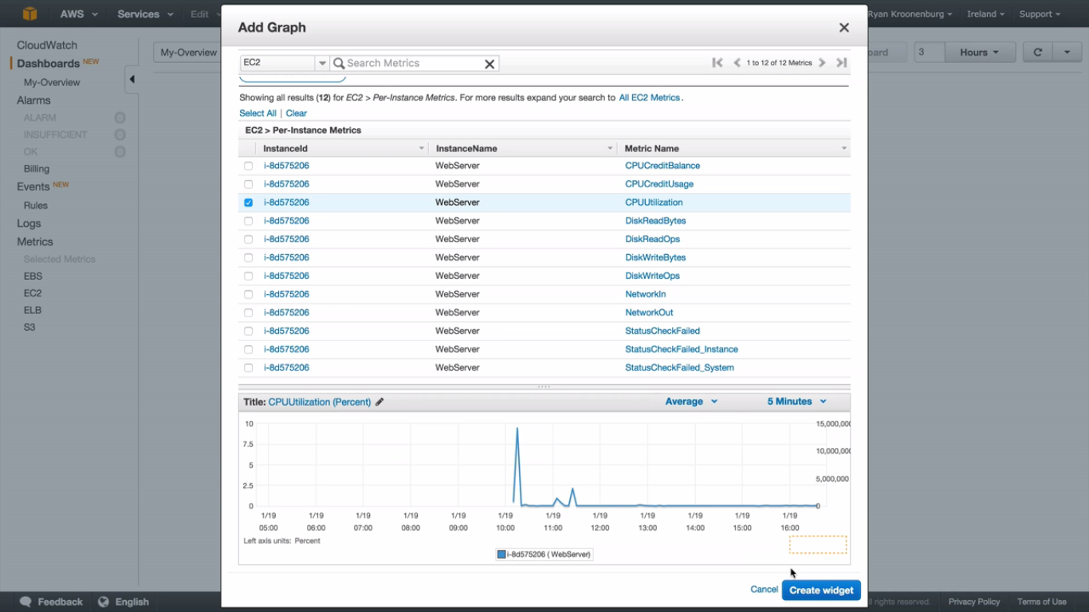In the same way you can add widgets to the same dashboard like below.

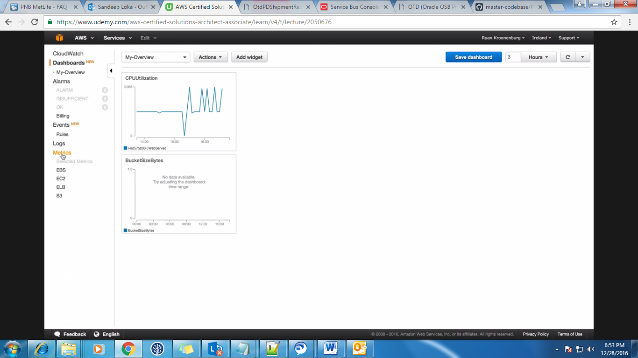The Events in the cloudWatch will help you to respond to state changes in the AWS resources.  
The Logs will help you to monitor the HTTP response codes in Apache logs.  
We can set the alarm also like whenever the CPU utilization is greater then 80% then send a mail and also stop the instance something like that.  
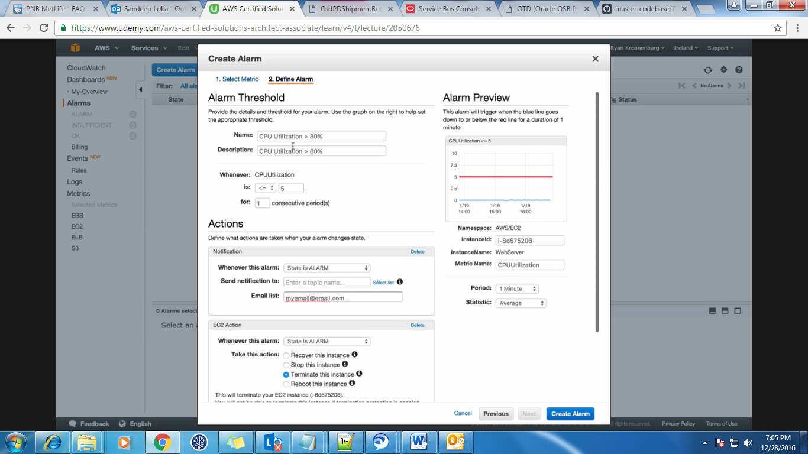

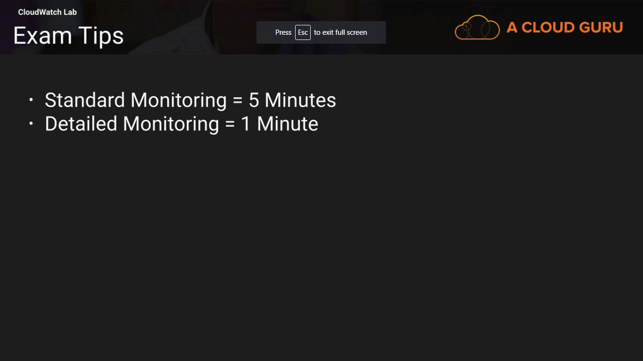

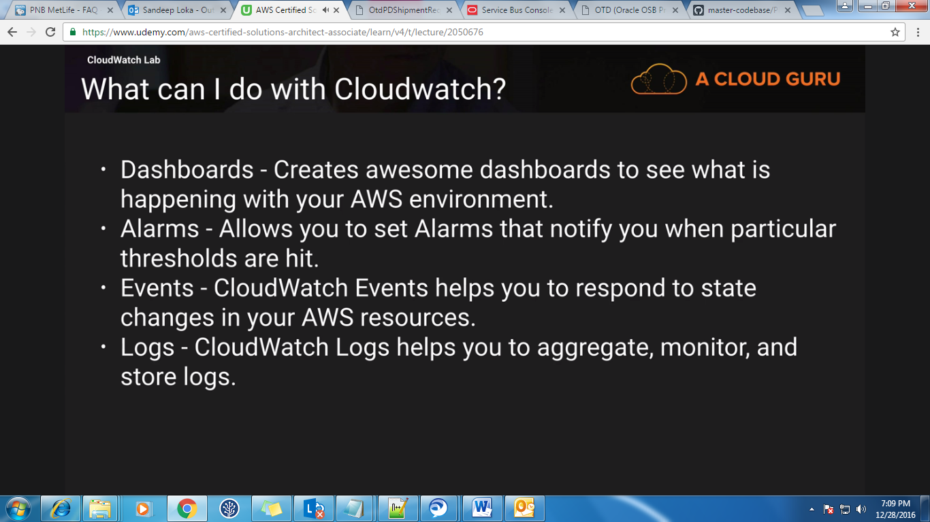

**Video 35:  
AWS Command Line and EC2:**Create a instance without any IAM role. After creating the instance go to security & identity and click on IAM and then create a user. Once the user is created download the credentials.  
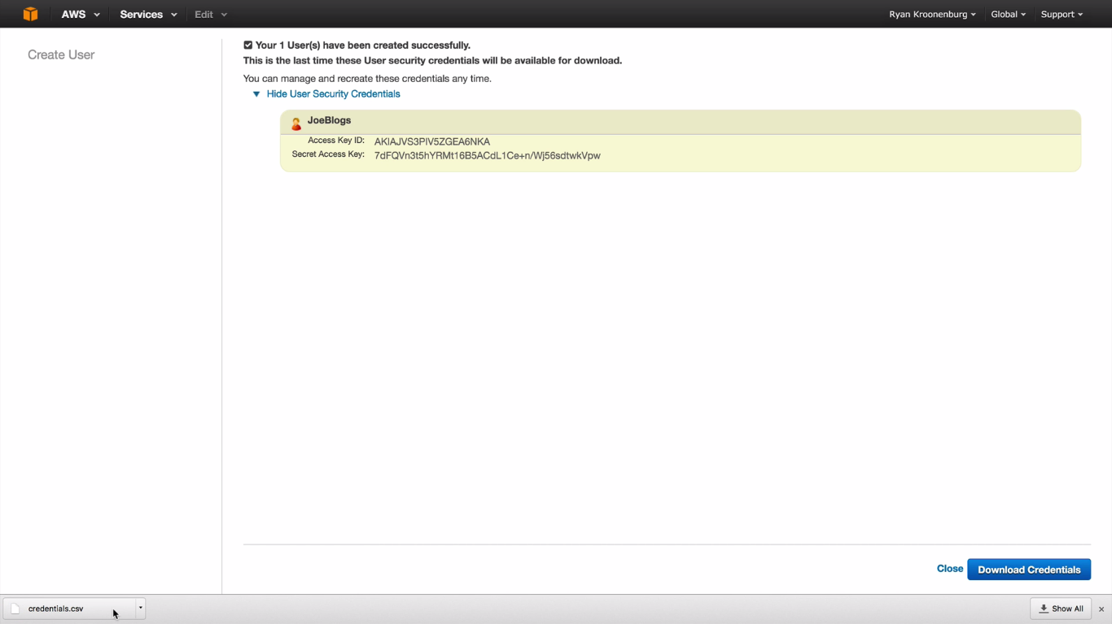

Now create a Group and attach the policy ‘AmazonS3FullAccess’ to this group and also the user created earlier to this group.  
Now go to the instance which you created earlier and observe that we have not applied any roles to this instance. And also you can’t add a role to instance once the instance is created.   
Now to configure aws on this instance, do the below steps.  
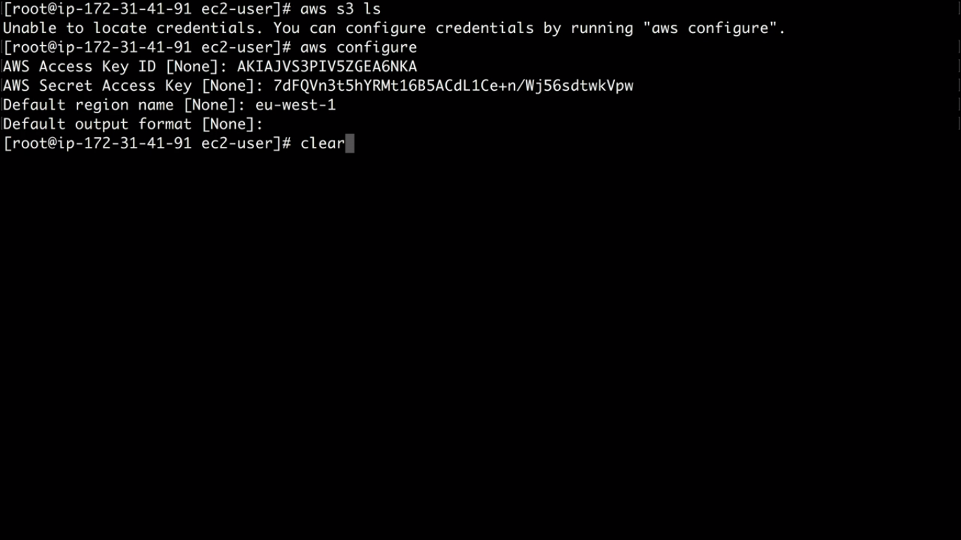  
Issue ‘aws s3 ls’ to know the list of buckets in S3 and if you want any help on the S3 commands then issue aws S3 help.

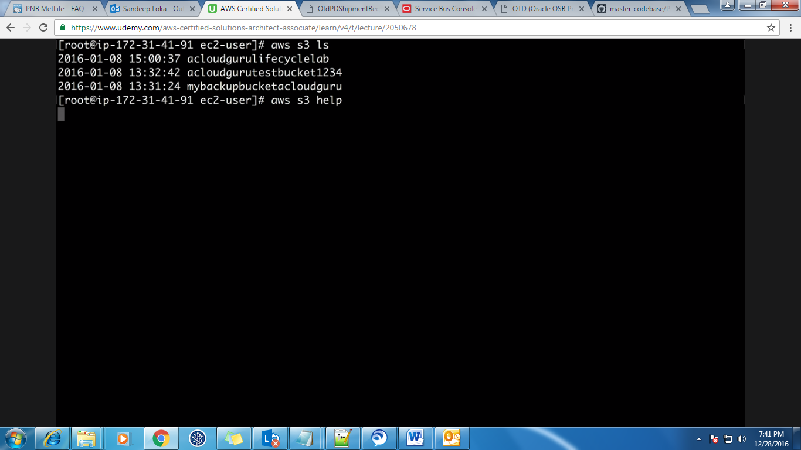mb- move bucket

We will have 2 files which stores the 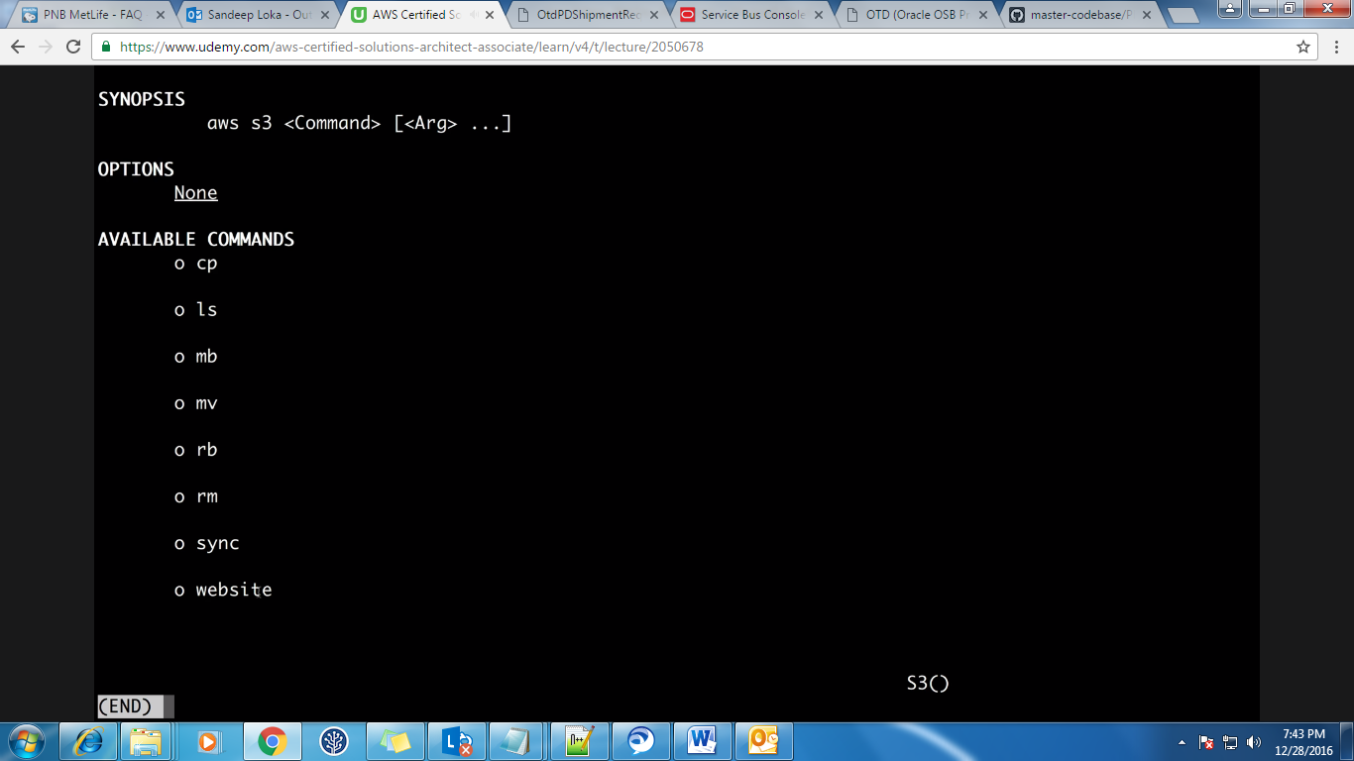credentials of this user and the files are **config** and **credentials**. In the credentials file you will have AK and SK.

**Video 36:**  
**Using IAM Roles with EC2:**Instead of having the **config** and **credential** file on the instance, it is better to attach the roles with instance. If we have these files on the instance then hackers may get those files and hack your instance. When you attach the roles with instance then you will not see them on the terminal.  
